**SPRINT - 1**

|  |  |
| --- | --- |
| Date | 13 November 2022 |
| Project Name | Smart Farmer - IoT Enabled Smart Farming  Application |
| TEAM ID | PNT2022TMID15139 |

**AIM OF THE PROJECT:**

For the increasing population growth and for the demanding food supply needs, the normal provisioning systems with existing methodologies seems to be unworthy and requires and advanced facilitations with optimal usage of water resources (irrigational resources). Hence a smart monitoring system of the farmland conditions and other subsidies may help us for a better productivity.

This could be made possible by sensing the physical parameters such as temperature, moisture and other soil parameters periodically and transferring over a user interface application could helps us to analyse the better situations of crop conditions.

**SEQUENCE OF PROCESS:**

Creating IBM Watson in IoT Platform:

* Go to IBM Cloud
* Click Catalog on top of the IBM Cloud and search IoT
* To create device, in the home page of IBM cloud click on the catalog on the top and click on IoT platform
* Click on launch button, then the IBM Watson platform will be displayed and Click on create device to create.
* After activating device simulator and check whether the code is running.
* Go to board and create a new board by filling the details
* Fill the detail to get temperature graph, select the color from the option and repeat the same process to get the humidity graph, we get the final graph.
* Finally an IBM Watson cloud for IoT and a device is created successfully.

Creating an account in IBM Cloud

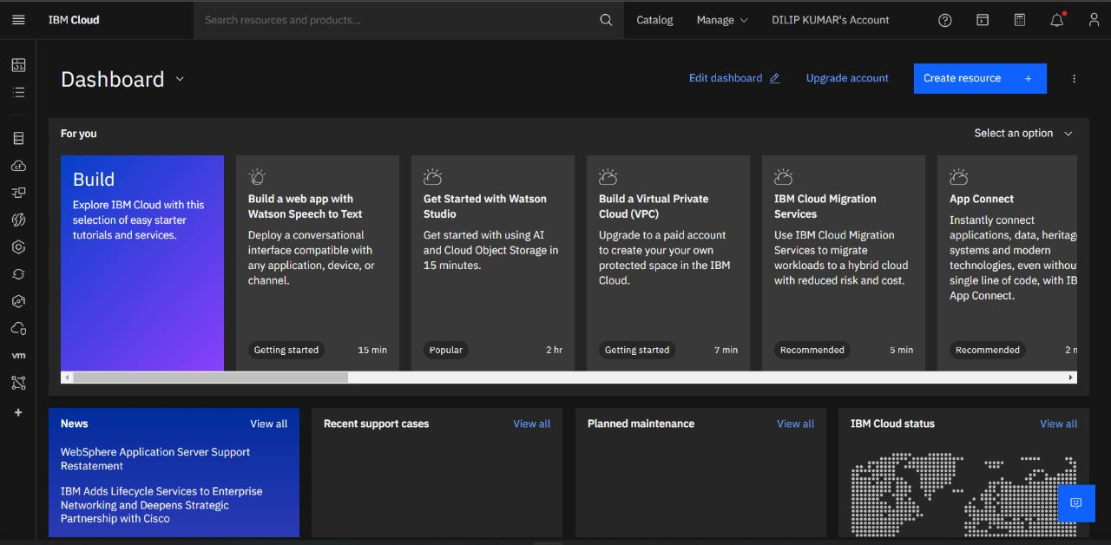

Creation of IoT Platform

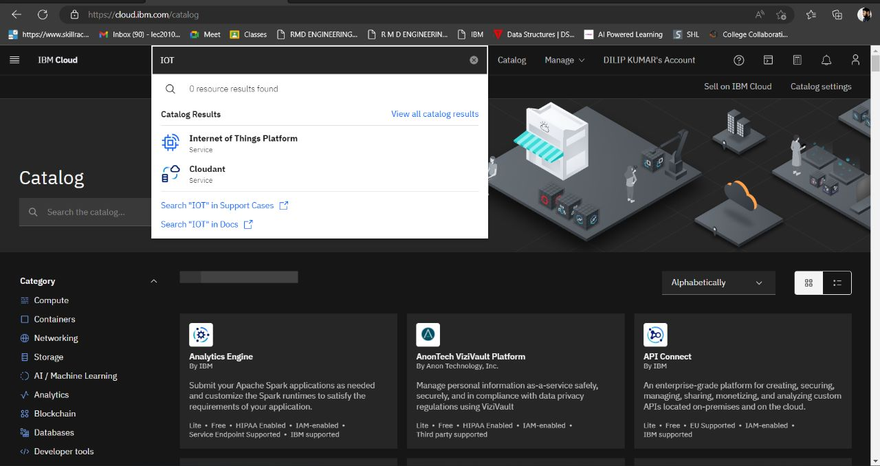

Launching of IoT Platform

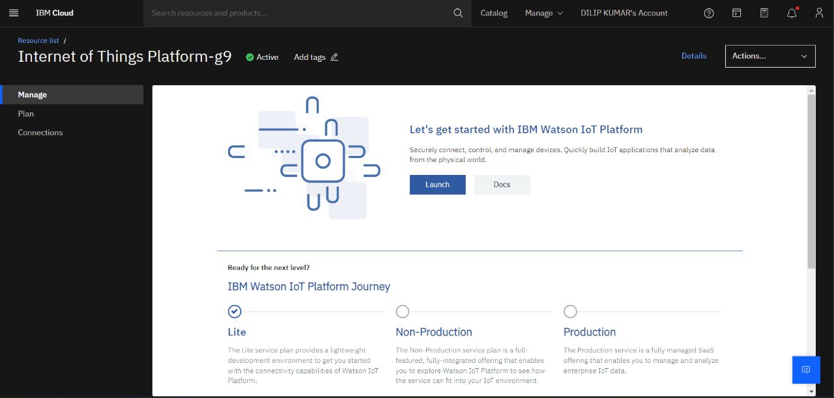

Creating Simulation for Smartfarm

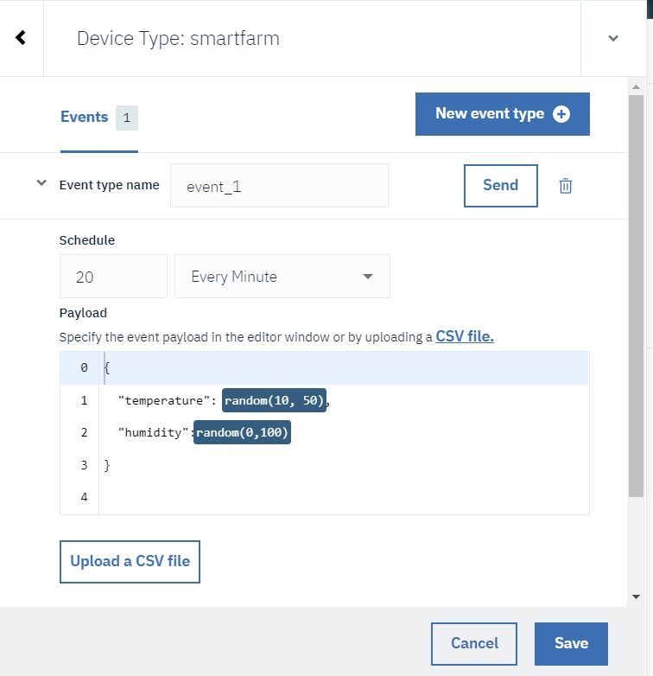

Security settings

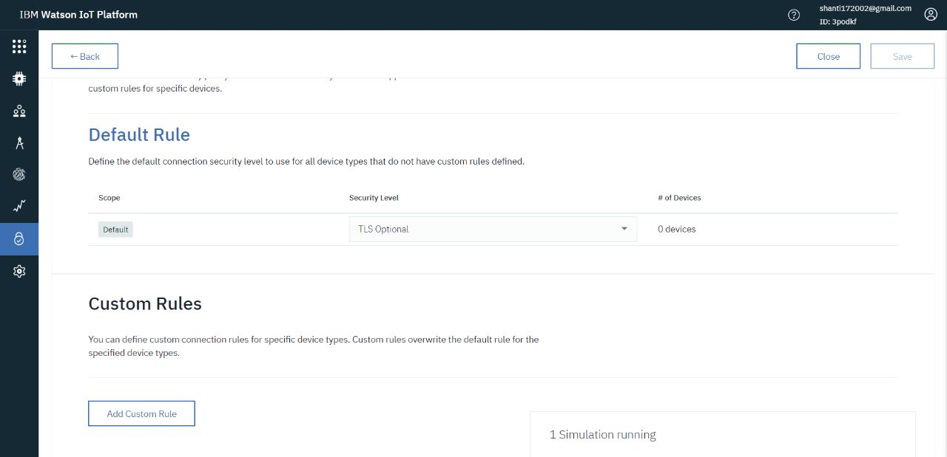

Device Configuration

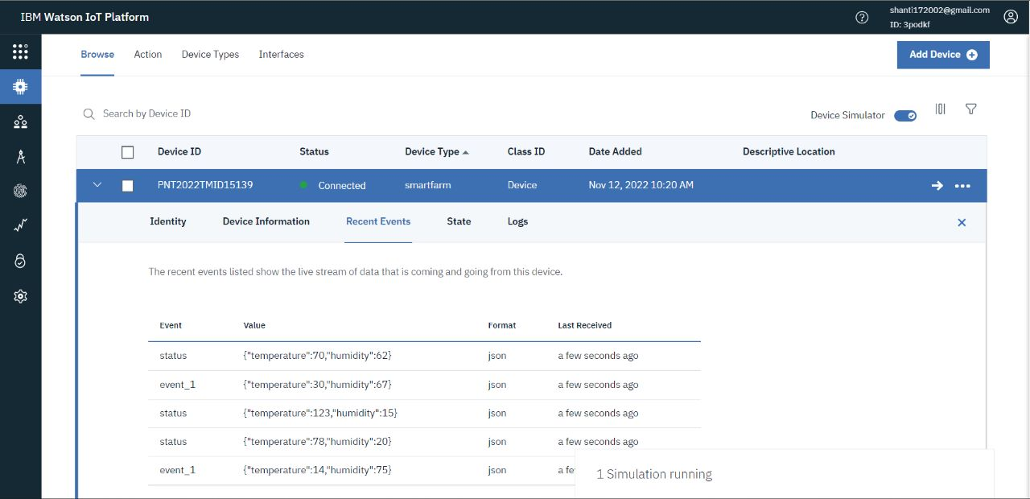

Monitoring temperature and humidity

